





World Airlines Club Association

Cairo & Nile Cruise

From 24 September to 30 September 2023

**Program:**

**Cairo Five Stars Deluxe Hotel:**

Sofitel Cairo Nile El Gezirah

First Stay: 24 - 25 September 2023.

Second Stay: 29 – 30 September 2023**.**

**Nile Cruise:**

MS/ Nile Premium Or MS/ Blue Shadow Nile Cruise.

From 25 - 29 September Five Stars Deluxe Nile Cruise.

**Day 1: Sunday 24 September**

* Meet and assist at the airport.
* 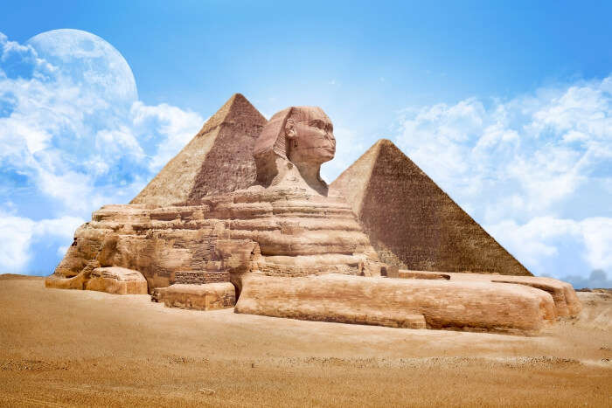Check in at **Sofitel** **Al** **Gezirah** **Five** **Stars** hotel and overnight.
* Back to the hotel for Overnight.

**Day 2: Monday 25 September**

* **Breakfast** at the Hotel.
* Tour to the **Great** **Pyramids** and the **Sphinx** **Sphinx.**
* **Lunch** at **Nine Pyramids Lounge Restaurant**.
* Transfer to the airport to fly to **Luxor.**
* Meet and assist at Luxor Airport.
* Check-in at **Five** **Stars** **Nile** **Cruise**.
* Visit **Luxor** **Temple.**
* **Dinner** on board.

**Day 3: Tuesday 26 September**

* **Breakfast** on board.
* 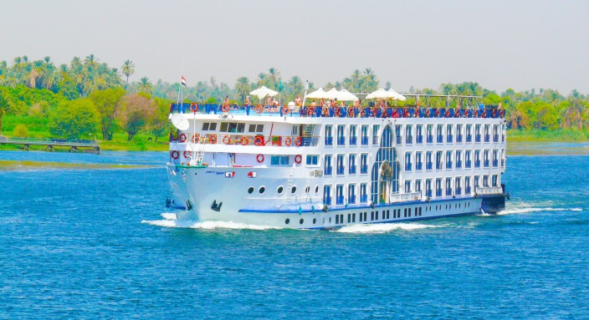Visit the West Bank (**Valley** **of** **the** **Kings**, **Queens Hatshepsut Temple**, **El**-**Deir** **El**-**Bahari**).
* Visit **Karnak** **Temple.**
* Having **lunch** on board.
* Sail to Edfu via Esna.
* Board afternoon tea.
* **Dinner** onboard.
* Overnight in **Edfu.**

**Day 4: Wednesday 27 September**

* 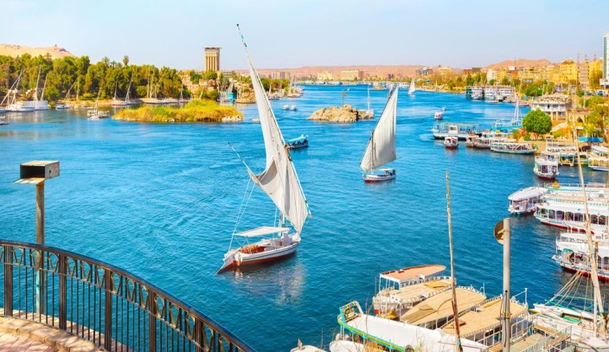**Breakfast** on board.
* Visit **Horus** **Temple** in Edfu.
* Cruise Sail to **Kom Ombo.**
* **Lunch** on board Visit the Temple which was shared by

the Crocodile and Falcon Gods.

* Sailing to Aswan and afternoon tea.
* **Dinner** on board and overnight in Aswan.

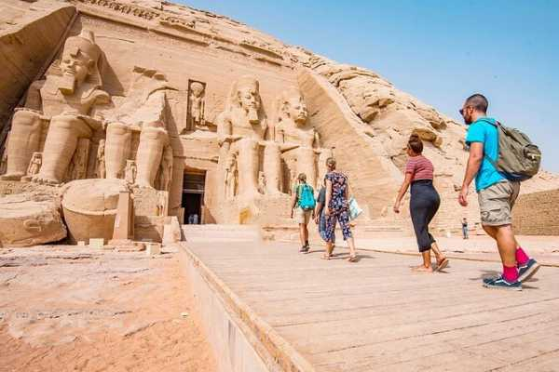**Day 5: Thursday 28 September**

* **Breakfast** on board.
* Visit the **High** **Dam**, **Temple** **of** **Philae** & **unfinished** **Obelisk.**
* **Lunch** on board.
* Afternoon tea.
* **Felucca** on the Nile around **Kitchener** **Island.**
* **Dinner** on board and overnight in Aswan.

**Day 6: Friday 29 September**

* 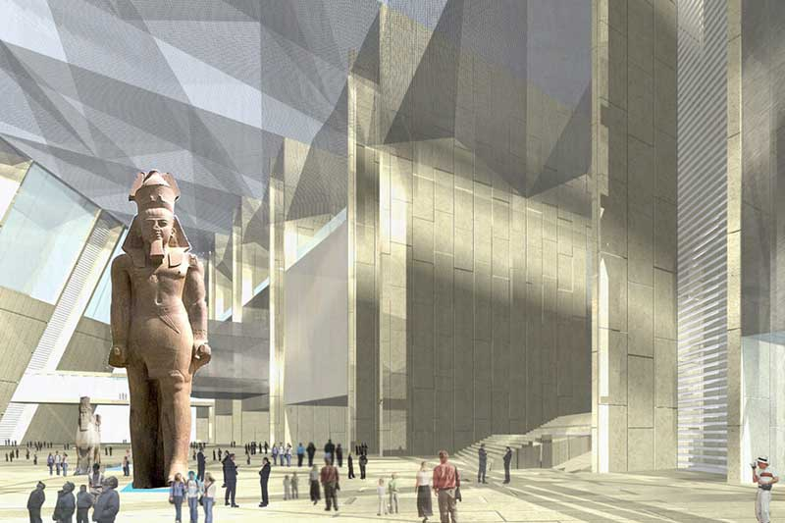**Breakfast** on board.
* Disembarkation After breakfast.
* Transfer to the airport to fly to Cairo.
* Meet and assist at Cairo Airport.
* Visit the **Grand** **Egyptian** **Museum** and the **Citadel**.
* Visit **khan** **El** **Khalili** **Bazar** and **Moez** **Street**.
* **Lunch** at **Nile** **City** **Restaurant**.
* Check in **Sofitel** **Al** **Gezirah** **Five** **Stars** **Hotel.**
* Nile **Dinner** Cruise with Oriental Show with Belly Dancer
* on board **Nile Pharaohs Cruise**.
* Back and overnight at Five stars hotel.

**Day 7: Saturday 30 September**

* Check-out and transfer to the airport for final departure.
* If time permits, enjoy a visit to the Hanging Church and St. Sergius Church before your flight departure.

**For reservation, please send your application to** [**JordanInterlineClub@gmail.com**](mailto:JordanInterlineClub@gmail.com)

**CC Yousef Suleiman yousef@brightravel.net**

**Package Prices:**

* Rate per person in double/twin occupancy is **USD 1,400.00**
* ***Early Bird rate for bookings and full payment by 31 March 2023: USD 1360.00 per person in a double room***
* Single supplement USD **450.00**
* Rate for extra night per double or twin room BB basis **USD 220.00**
* Rate for extra night for Single room is **USD 210.00**

**Rate Includes:**

* Hotel accommodation for 2 nights Cairo on BB bases at 5 stars hotel.
* Four night’s accommodation at five-star deluxe Nile cruise for full board bases.
* All mentioned sightseeing with English speaking guide.
* Dinner cruise with show.
* All required transfers as per above itinerary.
* Domestic flight ticket CAI LXR X ASW CAI.
* All Tips.

**Rate Excludes:**

* Fees for Entry Visa to Egypt Approx USD 25.00
* Any other sightseeing not mentioned at above itinerary
* All extras at hotel and at the Nile Cruise
* Travel insurance
* WACA fees USD 20
* Any type of drinks.

**Optional Tour:**

The optional tour to Abu Simbel includes land services, tour guide and entrance fees:

* By flight USD **350.00** per person (book in advance)
* By bus USD **150.00** per person.

**Kindly note the following if you are interested to visit Abu Simbel:**

* Bus trip to Abu Simbel from Aswan starts 5am in a convoy organized by the Egyptian Government.
* Bus trip duration is minimum 3 hours for one way and 2 hours visit (in total 8 hours to be back to Aswan by 01:00pm
* A private tour guide and a private driver will join you separately to Abu Simbel
* Minimum number to book this day trip is 2 persons.

**Important Notes:**

* Prices above are quoted in USD Per Person in Double Occupancy.
* Prices above are quoted based on a group of minimum 20 pax.
* **In case the Grand Egyptian Museum is still not opened, tour will be to the Old Egyptian Museum in Tahrir.**